[NAME]
[ADDRESS]
[CITY], [STATE] [ZIP]

RE: Your Right to Stop Paying Costly Union Dues

Dear [NAME],

I am writing on behalf of the California Policy Center, a non-profit educational foundation focused on protecting workers’ rights.

Two years ago, the United States Supreme Court issued its landmark decision in Janus v. American Federation of State, County and Municipal Employees, Council 31. In this decision, the Supreme Court confirmed that it was unconstitutional for public employers to deduct union dues fees from the paychecks of employees unless employees have given proper informed consent. Unfortunately, it has come to our attention that many state, county and municipality employers in California, including [AGENCY NAME], have not complied with Janus and are continuing to unlawfully deduct union dues and fees from employees’ paychecks without proper consent. Accordingly, we are writing to [AGENCY NAME] employees to inform them of their constitutionally protected rights and to arm them with the information necessary to exercise those rights.

What Are Your Rights Under Janus?

To exercise your rights under Janus, you cannot be a member of a union. If you are not a member of a union:

- Your employer cannot compel you to join a union as a condition of employment.

- You have a right to be union-free and to not pay the Union high dues and fees to keep your job, your wages or benefits. You have a right to understand that your union dues do not go towards any of your wages or benefits and that your wages and benefits will not be reduced if you choose not to be a union member.

- Your employer cannot compel you to make payments to a union, including but not limited to, union dues or fees.

- Prior to deducting any union dues or fees from your paycheck, your employer must inform you of the following: (1) under the First Amendment of the United States Constitution, you have a right to not authorize payroll deductions for union fees or dues and (2) if you authorize payroll deductions for union fees or dues, the union could use the money to fund a broad range of politically significant speech and activities, including those that you may disagree with.

- Prior to deducting any union dues or fees from your paycheck, your employer must obtain your informed written consent authorizing payroll deductions for union fees or dues.

- Upon your request, your employer must immediately stop making payroll deductions for union fees and dues.

What If I Am A Member Of A Union?

If you are a member of a union, your employer can continue deducting union dues from your paycheck. If you would like to stop paying union dues, you must:

- Resign your membership in the union.

- Once you resign your membership from the union, notify your employer that you have resigned your membership in the union and request that your employer immediately stop any and all payroll deductions for union fees and dues. Upon such notification and request, your employer must immediately stop all payroll deductions for union fees and dues.

If your employer continues to deduct union fees from your paycheck without proper authorization, tells you that you cannot stop paying union fees or dues, or claims that you will lose your job, salary or benefits if you stop paying union fees or dues, please contact the California Policy Center and we will help you exercise and enforce your constitutionally protected rights.

Sincerely,

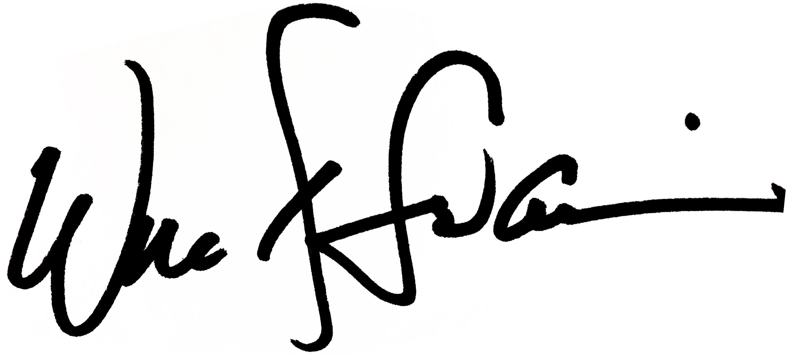
Will Swaim
President

