[NAME]
[TITLE]
[AGENCY]
[ADDRESS]

RE: Immediate Cessation of Unauthorized Deductions of Union Dues

Dear [NAME]

I am writing on behalf of the California Policy Center, a non-profit educational foundation focused on protecting workers’ rights. The purpose of this letter is to advise [AGENCY NAME] of its obligations to its employees following the United States Supreme Court’s decision in Janus v. American Federation of State, County and Municipal Employees, Council 31, No. 16-1466, 585 U.S. ___ (2018) (“Janus”). In this regard, we here by demand you cease and desist from any further interference with employees’ Janus rights and take immediate steps to properly inform employees of the process to exercise these rights.

- Under Janus, Public Employers Must Obtain An Employee Waiver Prior to Deducting Union Payments From Employee Paychecks.

Approximately two years ago, in Janus, the Supreme Court held that the First Amendment of the United States Constitution prohibits a public employer from deducting any union fees or dues from the paycheck of an employee who is not a member of the union, unless the employee waives his or her First Amendment rights. As the Supreme Court made clear in Janus, this requires the public employer to have clear and compelling evidence that the employee freely, knowingly, and affirmatively waives his or her constitutional protections and consents to the union payments before any money is deducted from the employee’s paycheck.

Importantly, the onus is on the public employer to ensure employees have effectively waived their First Amendment rights and consented to union deductions prior to making any such deductions. This means that [AGENCY] cannot rely on representations from a union that its employees voluntarily and affirmatively consented to the deduction of union payments. Nor can [AGENCY] rely on the fact that its employees have not affirmatively asked [AGENCY] to stop deducting union dues or fees following Janus. Rather, [AGENCY] itself must obtain an appropriate waiver from employees prior to deducting any union payments from their paychecks. Failure to do so is a violation of employees’ First Amendment rights and may expose [AGENCY] to a highly public, costly and lengthy litigation.

The requirements for an effective waiver are set forth below. [If][We understand] [AGENCY] has not obtained an appropriate and lawful waiver from employees who are not union members following Janus[,][and] we hereby demand that [AGENCY] immediately stop the unlawful and unconstitutional union deductions from those employees’ paychecks unless or until [AGENCY] obtains the required waiver.

- The Requirements For An Effective Waiver.

Waivers of constitutional First Amendment rights are not inferred lightly. “Rather, to be effective, the waiver must be freely given and shown by ‘clear and compelling’ evidence.” Janus, at p. 48.

- [AGENCY] Must Inform Employees About Their Rights Under Janus Before Employees Execute a Waiver.

The Supreme Court has long held that a valid waiver of constitutional rights must be a “knowing, intelligent act[] done with sufficient awareness of the relevant circumstances and likely consequences.” Brady v. United States, 397 U.S. 742, 748 (1970); see also Miranda v. Arizona, 384 U.S. 436, 444 (1966).. Stated another way, an employee’s waiver is knowing and intelligent when the employee has “a full awareness of both the nature of the right being abandoned and the consequences of the decision to abandon it.” Patterson v. Illinois, 487 U.S. 285 (1988).

To meet this standard in the context of union deductions, prior to executing a waiver, employees must be aware that (1) they have the right not to pay any money to the union, and (2) if an employee authorizes payroll deductions for union dues or fees, the union could use the money to fund a broad range of politically significant speech and activities, including those with which the employee may disagree. Thus, to avoid violating employees’ constitutional rights, [AGENCY] must affirmatively notify its employees of these rights before the employees execute a waiver and consent to union payroll deductions. If [AGENCY] fails to do so, the employees’ waivers will be invalid and any deductions will be unlawful.

Furthermore, [AGENCY] cannot assume that its employees understand their rights to refrain from paying union dues or agency fees or what that money may be used for. Nor can [AGENCY] rely on a union’s representation that the employees were informed of the necessary information prior to executing a waiver. Rather, under Janus, before [AGENCY] deducts any money, [AGENCY] must have actual evidence that employees have been fully informed of such matters. The only way for a public employer to meet this high burden is to affirmatively inform employees of these rights prior to obtaining an employee’s waiver.

- [AGENCY] Must Obtain a Written Waiver After The Employees Have Been Informed of Their Rights Under Janus.

After [AGENCY] informs employees about their rights under Janus, [AGENCY] must obtain a written waiver that certifies the employees voluntarily and affirmatively waive their First Amendment rights and consent to the union deductions. Only then will [AGENCY] be deemed to have the requisite “clear and compelling” evidence necessary to insulate it from a lawsuit.

Importantly, while the California legislation known as SB 866 purports that a public employer may rely on a union’s certification that an employee has executed an appropriate waiver, the union’s certification does not constitute “clear and compelling” evidence under federal law. By ceding the responsibility to obtain an appropriate and effective waiver to the union, [AGENCY] has no way to ensure the union explained to employees what their First Amendments rights are, much less adequately explained these rights. Likewise, because the union controls the circumstances in which the waiver is elicited, [AGENCY] has no way of knowing whether the waiver was the product of free and deliberate choice as opposed to coercion or deception. Thus, if [AGENCY] relies solely on the union’s representations regarding the effectiveness and circumstances of employees’ consent to union payroll deductions, [AGENCY] could be liable under federal law for violating employees’ First Amendment constitutional rights if the waiver obtained by the union is defective.

Accordingly, irrespective of SB 866 (which is clearly invalid and preempted by federal law), [AGENCY] must obtain a new, post-Janus written waiver after the public employer has fully informed employees of their rights under Janus.

- A New Waiver Must Be Obtained Whenever Circumstances Materially Change.

It is also important to note that constitutional waivers are not stagnant, one-time decisions. Rather, under established Supreme Court precedent, valid waivers of constitutional rights must reasonably contemporaneous. See Knox v. Service Employees International Union, Local 1004, 567 U.S. 298, 314-317 (2012); see also United States v. Nordling, 804 F.2d 1466, 1471 (9th Cir. 1986). This means that, when circumstances materially change or there has been a substantial passage of time since the employee’s waiver was executed, [AGENCY] must obtain a new employee waiver.

At the very least, this requires [AGENCY] to obtain a new waiver once a year. However, if circumstances materially change since the last waiver – for example, when the union raises its dues or levies a special assessment – [AGENCY] must obtain a new waiver based on these materially changed circumstances even though a full year has not passed since the employee executed his or her waiver.

- If An Employee Asks to Stop Deductions for Union Dues or Agency Fees, the Public Employer Must Immediately Do So.

If an employee asks to stop the deductions for union dues or agency fees, [AGENCY] must immediately stop the union deductions. The reason for this is because, once such a request is made, the public employer has actual knowledge that the employee does not consent to union deductions from his or her paycheck.

We note that SB 866 directs public employers to refer employee requests to stop union deductions to the union. However, this “fox guarding the hen house” approach does not alleviate [AGENCY]’s responsibility under federal law to immediately cease union deductions upon request by an employee who is not a member of a union. Thus, despite SB 866’s directive to refer such requests to the union, [AGENCY] must immediately stop deducting dues from the employee’s paycheck unless or until [AGENCY] receives a valid waiver from the employee to restart the union deductions. Once again, failure to immediately cease union deductions upon the employee’s request is a patent violation of the employee’s rights under Janus and may expose [AGENCY] to a liability on those grounds.

- Cease and Desist Demands.

Based on the foregoing, and to avoid potential costly litigation, we hereby demand [AGENCY] immediately stop the continued infringement of employees’ First Amendment rights and implement the following measures:

- Immediately stop all payroll deductions for union dues or fees from employees who are not union members or from whom the Agency has not directly and recently received a valid, knowing waiver.

- Inform all union represented employees of their constitutionally protected rights, as articulated in Janus, that (1) they have a First Amendment right to not join or be a member of the union, (2) under the First Amendment, employees who are not members of the union cannot be compelled to pay money to a union, and (3) if employees choose to waive their First Amendment rights, the union could use the money to fund a broad range of politically significant speech and activities, including those with which the employee may disagree. For [AGENCY]’s convenience, we have enclosed an employee communication that [AGENCY] can use to inform employees of these rights.

- Obtain a new written waiver in which the employee waives his or her First Amendment rights and consents to union deductions.

- Institute a program to at least annually inform employees of their rights.

To avoid a costly, highly public and lengthy lawsuit for violations of employees’ constitutionally protected rights, please confirm that [AGENCY] has taken these actions by no later than [DATE]. Should you have any questions or would like to discuss these issues further, please do not hesitate to contact me.

Sincerely,
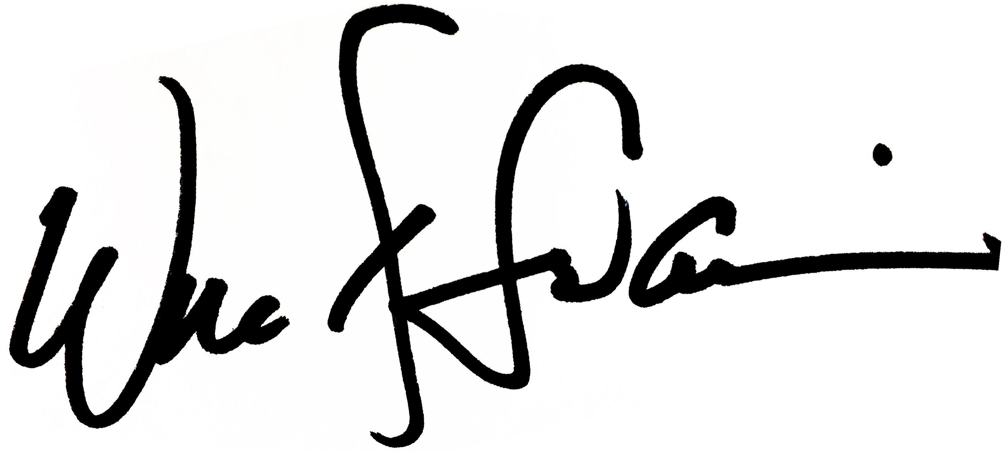
Will Swaim
President

